SYSTEM AND METHOD FOR A SECURE DUAL-ARCHITECTURE OFFLINE-FIRST PLACEMENT PREPARATION PLATFORM INCORPORATING NATIVE BIOMETRIC LOCKS AND A CLIENT-SIDE EXAM INTEGRITY SUITE
1. ABSTRACT OF THE INVENTION
This invention discloses a secure, unified dual-architecture offline-first placement preparation and assessment platform functioning both as a client-side mobile application wrapper container and as a responsive web portal. The system is designed to provide secure training and technical evaluation workspaces entirely client-side, eliminating cloud server dependencies. In the mobile architecture, a native security wrapper built in Kotlin intercepts launch commands, prevents screen capture using secure Window flags, and prompts biometric credentials verification (fingerprint, PIN, or pattern). Upon authentication, the native wrapper loads a hardware-accelerated WebView engine, which reads compiled training files offline from the internal assets folder via a specific file path (file:///android_asset/appti/index.html) with zero API delay. In the responsive web architecture, the application functions as a self-contained responsive web portal deployable on web servers, accessible on desktop and mobile browsers, utilizing browser-level window blur and document visibility state listeners to secure exams. The system detects if it is running in the native wrapper or web portal by checking for the User Agent parameter ('VetriPathApp') or path string ('android_asset') to dynamically adjust navigation layouts. The workspace includes Quantitative Aptitude, Logical Reasoning, and Verbal Ability practice boards, along with a sandbox Javascript coding console. Progress records (bookmarks, wrong answer history) are serialized into JSON and synchronized locally in the device's browser cache (LocalStorage), creating a serverless, distraction-free, and cheat-proof e-learning system branded under the name VetriPath and identified by a visual branding logo.

2. FIELD OF THE INVENTION
The present invention relates generally to educational testing systems, and technical assessment sandboxes. More specifically, this invention relates to a secure dual-architecture platform that packages web training components into both a secure native mobile application wrapper and a responsive web application/website, executing logic, database syncing, and exam focus-integrity monitoring entirely on the client side, branded with a specific name ('VetriPath') and proprietary visual logo design.
3. BACKGROUND OF THE INVENTION
Standard career training portals, technical assessment environments, and placement mock simulators exhibit major functional limitations:
- High Server and API Latency Dependency: Existing systems require persistent connection to remote web servers to query questions, run compilers, and write progress metrics. In areas with weak telecommunication networks, page timeouts, data loss, and execution lockouts are frequent.
- Distracting Content and Advertisements: Standard free preparation sites rely on heavy ad banners and notification pop-ups. These consume device RAM, slow down performance, and disrupt candidate learning.
- Vulnerable Exam Sandboxes: Standard browser wrappers allow candidates to cheat during mock assessments by copying text, inspecting developer tools (F12) to reveal correct answers, or switching tabs to run search queries. This invalidates performance logs.
To address these drawbacks, the present invention integrates a dual-architecture implementation. It provides a secure, fully functional native wrapper for mobile devices alongside a responsive desktop/mobile website portal. Both utilize client-side JavaScript database serialization and event-based cheating prevention hooks, delivering zero network overhead and verified assessment statistics under a unified branding identifier.
4. OVERVIEW OF THE PROPOSED SYSTEM
The proposed system, VetriPath, implements a dual deployment shell that hosts an identical, compiled offline-first core web workspace:
4.1. Mobile Application Wrapper Architecture
In the mobile wrapper architecture, a native Android shell is built in Kotlin and Jetpack Compose. When initialized, the wrapper sets window flags to FLAG_SECURE, blocking screenshot utilities and screen recorders. It loads the Android Jetpack Biometrics SDK to prompt biometric credentials (fingerprint scanner, PIN, or pattern) before rendering the main view.
Upon successful authentication, the native wrapper mounts a hardware-accelerated WebView engine. This engine enables Javascript execution, DOM storage, and universal file access to load compiled training assets offline. The web path loaded in the wrapper is: file:///android_asset/appti/index.html. This is a verified local Android asset URL, meaning the application reads all HTML, CSS, JavaScript, and question library files locally with zero network queries or latency.
4.2. Responsive Web Portal Architecture
In the web portal architecture, the workstation functions as a self-contained responsive website deployable on standard web servers. The website uses standard CSS grid layouts and media queries to adapt to desktop viewports, laptops, and tablets. It executes the identical client-side database module (storage.js) and coding compilation sandbox. Rather than relying on native device locks, the website architecture secures exam mock tests by attaching window focus-loss listeners, securing the assessment environment directly within the browser shell.
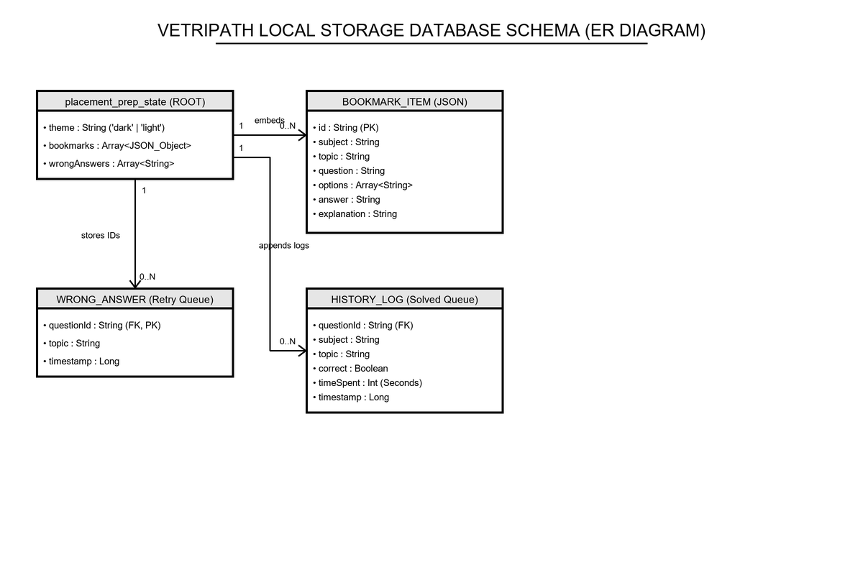
Figure 1: Entity-Relationship (ER) Diagram representing the VetriPath local storage database schema.

5. TECHNICAL DESCRIPTION OF SYSTEM MODULES
VetriPath compiles and runs core training panels client-side, sharing resources between the native shell and the responsive website:
- Aptitude practice panels (aptitude.html, reasoning.html, verbal.html): Houses multi-choice questions covering 30 topics. An offline database generation module (mock_data_gen.js, quiz.js) handles questions selection dynamically.
- Coding playground workspace (coding.html): Embeds a JavaScript sandbox interpreter compiler. The workspace parses programming challenges, compiles user inputs, runs test cases, and logs outputs locally using window-level compilation modules (coding_runner.js).
- Local Storage DB (storage.js): Implements a client-side JSON database schema serialized as 'placement_prep_state' in the browser cache, tracking streak days, bookmark objects, incorrect questions queue, and practice logs.
- Adaptive Integration Styling (app.js): Dynamically detects host configurations during DOM initialization. If the browser URL contains the string 'android_asset' or the browser user-agent matches 'VetriPathApp', a native-specific styling override is injected into the head (e.g., '.web-only { display: none !important; }'), hiding web-only portal controls from the mobile application WebView interface.
6. WORKING OF THE PROPOSED SYSTEM WITH WORKFLOW
The operating workflow of the dual-architecture system details the boot-up and security cycles for both configurations:
6.1. Mobile App Workflow
- 1. Initialization and Shielding: The user launches the VetriPath app. MainActivity.kt sets FLAG_SECURE window state and displays the splash screen.
- 2. Credentials Authentication: The app triggers a BiometricPrompt request. Successful authentication transitions the state to load the WebView layout.
- 3. Offline Resource Loading: The WebView mounts, initializes DOM caching, and calls loadUrl('file:///android_asset/appti/index.html'). The verified path, matching our codebase's MainScreen.kt implementation, loads the offline index shell.
- 4. Styling Adaptation Check: The client script app.js checks if window.location.href contains 'android_asset' or if navigator.userAgent matches 'VetriPathApp'. It dynamically injects styling rules to hide web-only menu items, adjusting layout constraints.
- 5. Workspace and Security Enforcements: When starting a mock test, CheatingProtection.enable() disables right-clicks, copy, cut, paste, text selection, print-screen, and developer shortcuts.
- 6. Blur Auto-Submission: If the candidate navigates away from the WebView (switches apps, answers calls, or pulls down notification logs), window.blur and visibilitychange events fire. The mock test is instantly submitted and locked.
- 7. Local DB Sync: Test scores update local storage, sync with the dashboard state, and save to the 'placement_prep_state' JSON record.
6.2. Responsive Web Portal Workflow
- 1. Browser Mounting: The user accesses the web server URL. The responsive home dashboard loads, rendering a glassmorphic dashboard.
- 2. State Loading: The database controller (storage.js) reads progress data directly from browser cache.
- 3. Exam Security Enforcements: When launching a mock test, the page requests fullscreen execution. The cheating protection suite attaches visibility change and blur event listeners.
- 4. Auto-Submission on Tab Switch: If the user shifts focus to another tab, minimizes the browser, or opens developer tools, visibilitychange and window.blur hooks intercept the focus loss. The mock test logs the violation, prompts a toast notification, submits the exam, and displays the final score dashboard.
- 5. Database Sync: Results are serialized and saved to LocalStorage, keeping progress synced across practice sessions.
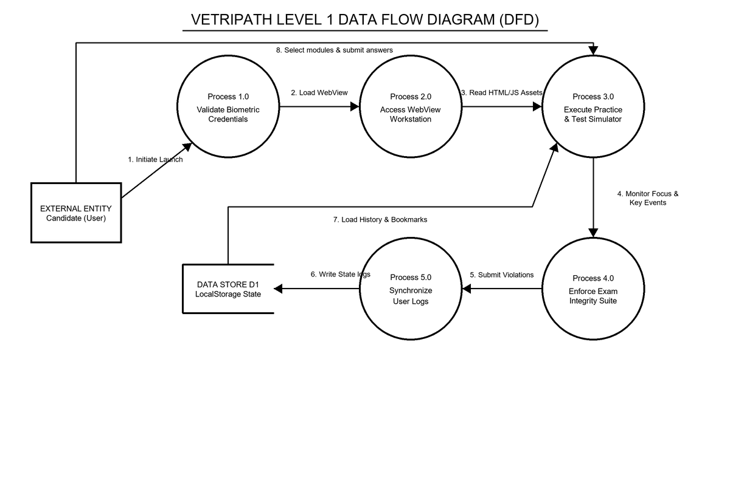
Figure 2: Level 1 Data Flow Diagram (DFD) showing security wrapper boundaries and local data loops.

7. SYSTEM INTERFACE SCREENSHOTS
The screenshots captured below show original data from the running application interfaces:
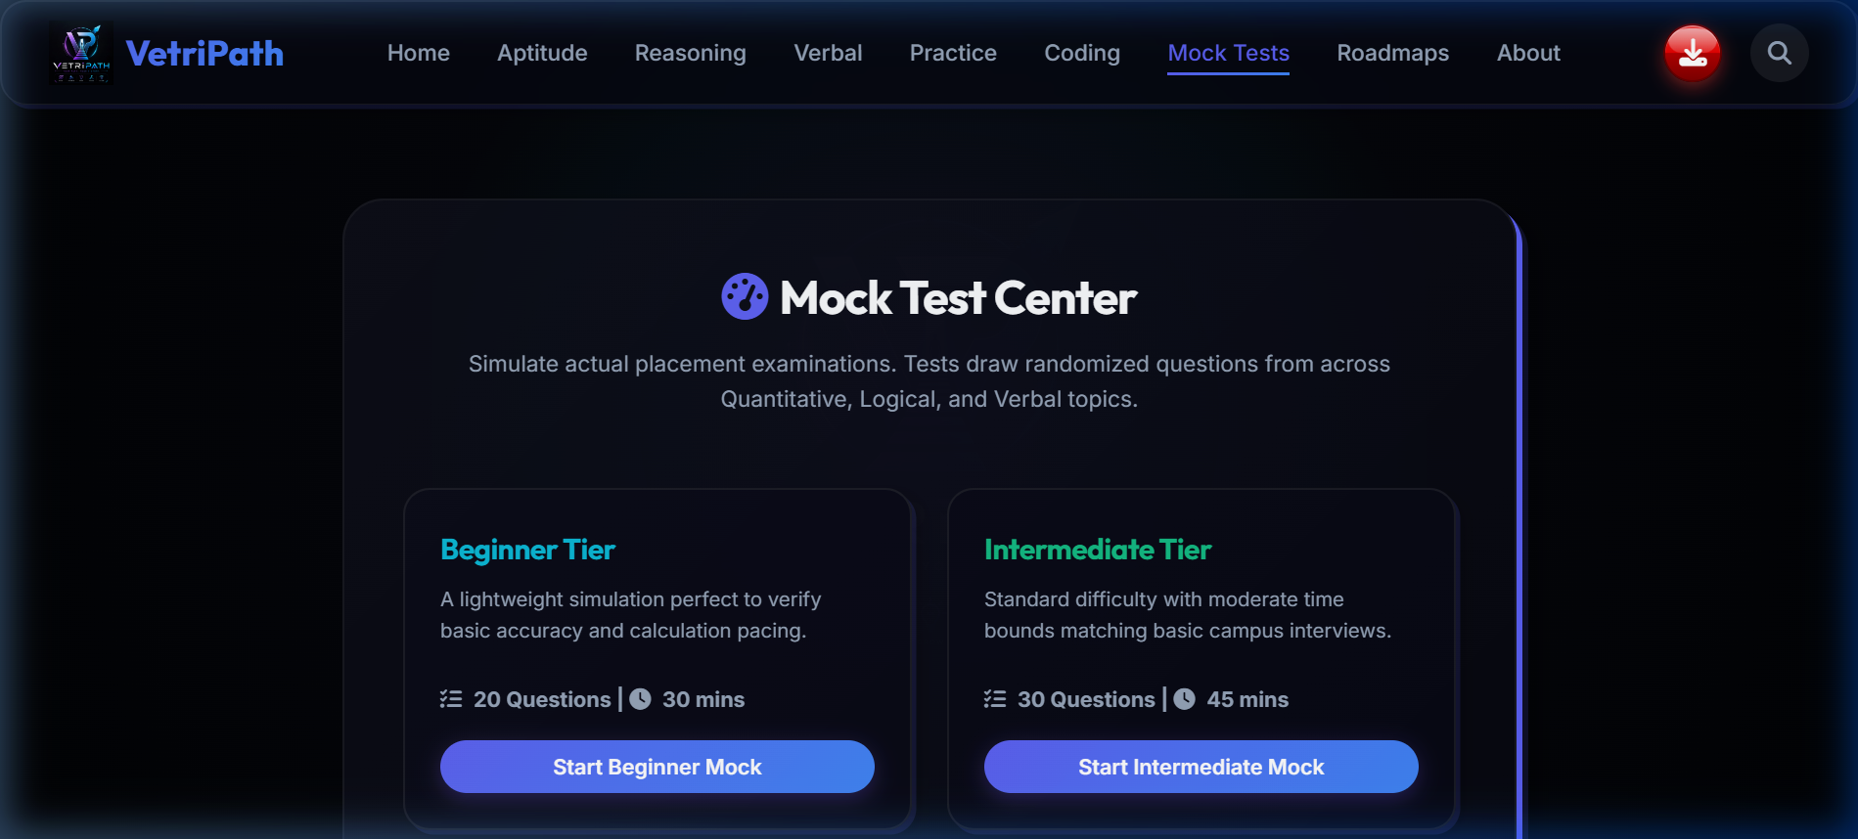
Figure 3: Mock Test Center Panel (Input dashboard showing beginner, intermediate, advanced, and full length mock test configurations).
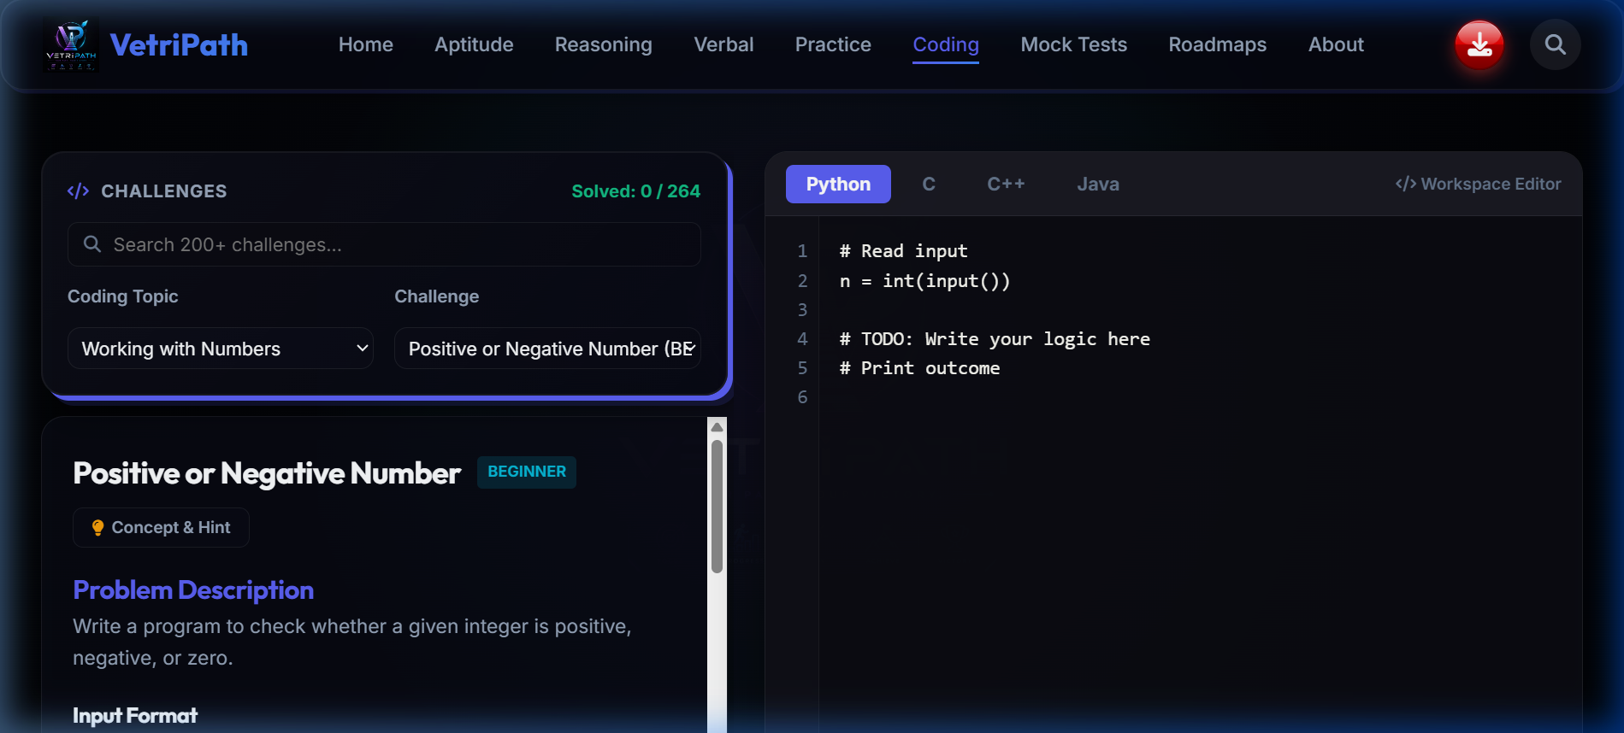
Figure 4: Coding Sandbox Workbench (Compiler playground showing the challenges panel, editor, and console run controls).

8. RESULT SUMMARY OF THE INVENTION
The dual-architecture system VetriPath provides several advantages over standard web prep dashboards:
- Serverless Operations: The application reads and writes logic entirely on the client, eliminating API delays, server database overhead, and network crashes.
- Unified Cross-Platform Core: Both the Android app and the desktop portal run the identical web workstation core, simplifying updates.
- Enforced Assessment Fairness: The exam simulator prevents copying, print-screens, and tab switching, securing mock test metrics.
- Hardware-Level Security: Mobile wrappers block screenshot tools, protecting question database ownership.
- Branding Authenticity: The visual logo design and 'VetriPath' name identifier are rendered across splash views and active layouts to confirm platform legitimacy.

9. CLAIMS OF THE INVENTION
We Claim:
1. A secure, dual-architecture offline-first placement preparation and assessment platform, comprising:
- a native application security wrapper constructed to block screen captures, prompt native biometric verification before load, and host a hardware-accelerated WebView container;
- a responsive web application shell deployable on web servers and executable on desktop and mobile browsers;
- an identical compiled training workstation bundle loaded locally inside said WebView container via the path file:///android_asset/appti/index.html or accessed via standard web server routes, containing aptitude boards and a JS coding playground; and
- a database controller serialized as JSON in browser cache (LocalStorage), saving progress records client-side with no cloud dependency.
2. The platform of claim 1, wherein said native application security wrapper sets secure layout flags on MainActivity creation to prevent screenshots and screen recordings.
3. The platform of claim 1, wherein said native application wrapper prompts native biometric prompts via the device hardware credentials SDK, verifying the candidate before loading WebView processes.
4. The platform of claim 1, wherein said responsive web application shell adapts to desktop, laptop, and tablet screens using responsive CSS grid parameters, running standard browser storage APIs directly.
5. The platform of claim 1, further comprising a cheating protection suite, wherein the suite disables context menus, text selection, copy, cut, paste, PrintScreen, and developer tools shortcuts during mock assessments.
6. The platform of claim 5, wherein said cheating protection suite listens to document visibility states and window blur events, automatically submitting the active exam immediately upon focus loss, tab switching, split-screen activation, or browser minimizations in both mobile and web configurations.
7. The platform of claim 1, wherein said native application security wrapper and said responsive web application display a specific branding graphical logo and a proprietary brand name 'VetriPath' on splash views, lock screen overlays, and navigation header fields to identify the platform source.
8. The platform of claim 1, wherein the background layout of said native WebView container and said responsive web application dynamically displays a faded visual watermark of said graphical logo behind active text panels, training modules, and assessment scorecards to reinforce branding presence.

